|  |  |  |
| --- | --- | --- |
| **FORECAST DATA COLLECTION**    Scanning Mushroom Beds |  |  |
|  |  |
|  |  |

People involved:

AG team: Faraz , Ayan

UoL team: Ajay, Jason

1. The experiment name

Scanning Mushroom Bed experiment 1

1. Experiment rationales

Collecting data from mushroom beds before and while mushrooms be picked; the

mushroom beds should be on the first and second flushes. The collected data will be

used to estimate the mushroom growing rate (MGR); the targeted mushroom size is

between 15 mm and 80 mm. The collected data will include RGP images and depth

information from the whole bed; in addition to environment information which will be

captured using a set of sensors. The mushroom bed forecasting will be recorded and the amount of picked mushroom per day or between scanning will be also recorded.

Plan in snapshot:

In each time-step scan all available mushrooms will be compared in terms of growth in

4 hours to find out growth rate. Growth rate will be calculated for individual sizes. Based on that, forecast data would be constructed, and depending on that data, the model

would be architected.

1. Methodology involved in the test
2. **Method**

a. Select two tunnels for scanning: one in first flush and second in second

flush.

b. Prepare harvester for data scanning in the first tunnel before 8am

c. Collecting mushroom size data (time series data) from the first flush and 2

flush.

d. Preparing a harvester for scanning required 20 minutes.

e. The scanning of a bed will required 15 minutes;

f. Moving a harvester from one tunnel to another tunnel required vary time

based on the distance between tunnels but on average it will be 20

minutes.

g. Data collected will start day before picking and continue until the end of

flush period.

h. Data collected per day will be scheduled as following:

i. Flush 1: scan at 8 am, 12 pm and 3 pm

ii. Flush 2: scan at 9 am, 10 am and 5 pm

i. Collect environment information using a set of seniors which are:

i. Temperature

ii. Humidity

iii. CO2

iv. Compost temperature and moisture

v. Air flow near on bed

j. The mushroom bed furcating will be recorded before the start of scanning

and picking.

k. The weight of picked mushrooms between the scanning will be recorded.

l. The total weight of picked mushrooms according to various grade will be

recorded.

m. The picker performances/costs will be recorded.

1. **Hardware** **involved**:

MK1 will be used for scanning the bed. Prior to the first day of data collection or

scanning, MK1 will be prepared to perform necessary operations like scanning

while mobbing across the bed or the shelf.

1. **Storing LMF forecast data and scan data day by day along side pre and post picking data**:

Each day, at specific intervals (if possible) scan data would be taken from a shelf or a bed and growth of individual mushrooms will be targeted to be evaluated. This growth rate of various mushrooms would be used as input to the forecast model. Below is a sample how scan needs to be done over time. For forecast scan we need 3 scans starting from 8 am to 5 pm.  One at 8 am following at 12 pm and the last one being at 4 pm.

There will be pre and post picking scan for picking data collection either. This scan timing will be adjusted on daily basis depending on picking sessions.

|  |  |  |  |
| --- | --- | --- | --- |
| **Scan​** | **Time​** | **Total scans​** | **Per day scans** |
| Forecast scan​ | Flush 1: 8am​,12pm,3pm  Flush 2: 9am,10pm,5pm | 3 per flush | 6 |
| Pre post scan​ | 8-11 am , 11-2pm, 2- 5pm | 3 pairs of pre and post | 6 |

​

Setting up the Harvester and scanning the entire shelf would take approximately 30 minutes.​

1. 3 times regular/irregular forecast scan ​
2. Options for modelling:  Based on the frequency and time intervals of data collection. (To be decided along with the Farm)​
3. Feed Regular time intervals data to the model.​
4. Manipulate the irregular time interval data to make it regular and then feed it to the model.​
5. Feed the irregular time interval data to the model. Need to find the suitable model that accepts irregular time interval data.

|  |  |  |  |  |
| --- | --- | --- | --- | --- |
| **Day​** | **Flush​** | **Tunnel state​** | **Key task​** | **Side task​** |
| Day 1​-2 | N/A | N/A | Setting up MK1 for scanning | N/A  (Setting up will be done at farm arranged space) |
| Day 3 | Flush 2/1​ | 1 day prior to 1st day of harvest (No picking involved) | Preparing Harvester for scanning | Doing necessary arrangements for head start |
| Day 4-6​ | Flush 2/1​ | 1-3 days of harvest (Picking involved) ​ | Scanning the bed and collecting data ​ | Monitoring data, data storage management, Data analysis, demonstrating farm pre-post count vs bin-size histogram |

1. **Data** **storage**:

Scan data will be tagged by data and time so that fetching particular data at a particular time stamp becomes easy and accessible without cross linking to each other within the storage.

There has been a 1TB hard drive arranged for data storage. Each day, scan data will be transferred from MK1 computer to the hard drive. This drive will provide source for data utilisation and analysis.

1. **Time** **base** **plan**

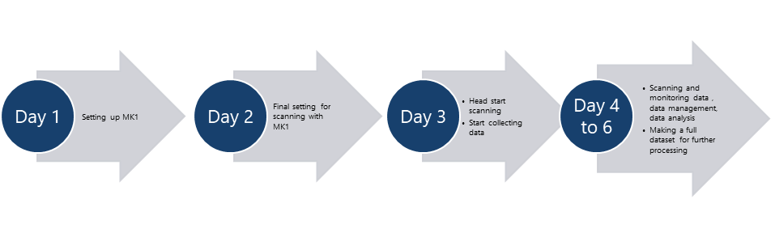

[**Ghantt Chart**](https://universityoflincoln-my.sharepoint.com/:x:/g/personal/akundu_lincoln_ac_uk/EXyVHZn6SrtDp466ttIf7TgBesqrFQJ79eY73Dk08UBhfw?e=CZWEWy)

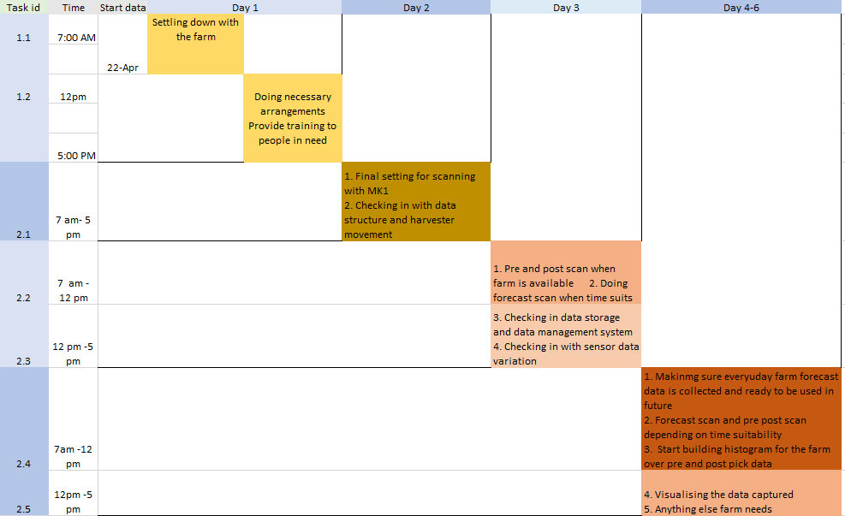

|  |  |  |  |
| --- | --- | --- | --- |
| Events | | | |
| Preparation | Forecast | Pre and post scanning | Data analysis |
| Day **1** Day **2** | Day **3** to the last day (Day**5/6)** | Day **3** to the last day (Day**5/6)** | Day **4** to the last day (Day **5/6)** |
| * Setting up MK1 * Doing necessary arrangements * Training over handling MK1 | * Forecast scan with intervals * Check in with Data structure * Doing necessary adjustments * Making sure everyday forecast scan data is accompanied by farm forecast data | * Pre and post scan * Check in with Data structure * Doing necessary adjustments * Start building histogram for the farm * Visualising the data being captured | * Visualising the data being captured * Making sure everyday forecast scan data is accompanied by farm forecast data * Anything else farm needs |

1. H&S Risk assessment and training

For this experiment existing AR risk assessment would be used.

Ayan and others involved in this experiment will be trained by AR team who have already used the harvester MK1 previously at the farm

1. Requirements from LMF
2. **Forecast:** ​
3. Forecast for the targeted bed before scanning and picking
4. **Environmental** **sensor** **data (Growing card):​**
5. Environmental data from the tunnel where the scanned bed located
6. **Weight data**:​
7. The weights and the sizes of picked mushrooms between the scanning.
8. Record after pick weight and passes involved every pick
9. The total weights of picked mushrooms according to various grade.
10. The picker performances/costs.
11. Expectation and probable outcomes

With this experiment a time series dataset with specific intervals having mushroom growth over time is the major expectation. Alongside this pre and post picking scan would be done and the farm will receive a histogram of mushroom size bins before and after picking

1. 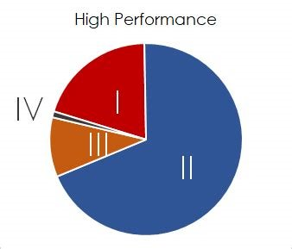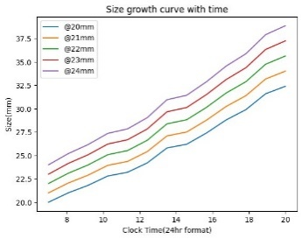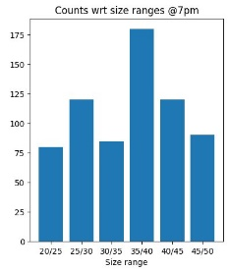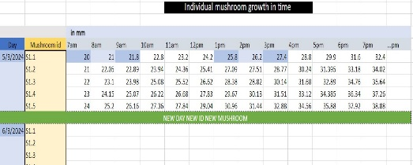

1. Factors handled by the scanning team
2. Preparing MK1 ready for scanning​
3. Selecting suitable tunnel ​
4. Data storage system ​
5. Arrangements​
6. Tools required: MK1 harvester, cameras set up on to the frame, storage for storing scan data​
7. Days of stay at the farm: *5-6 days* – 1 day prior to first day of harvest to next 5 days of harvest period​
8. Work time span each day: apparently 8*am to 5pm* (9 hrs)​
9. Scan time: It seems a full shelf scan would take roughly 20-30*min*​
10. Flush: scanning will start with flush 2, following flush 1​
11. Location of work: *tunnels* that satisfies the above​